AVAILABLE FULLDOME PROGRAMS
Fulldome Program | Description
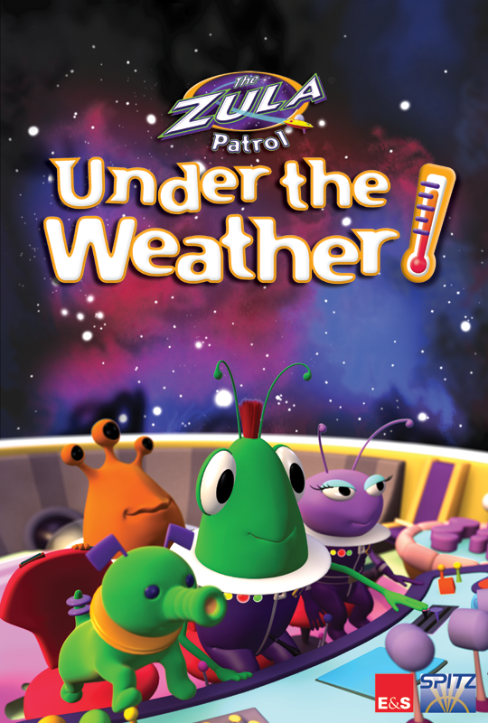  Pre K - Grade 4: ZULA PATROL: UNDER THE WEATHER (23 min) | The story: the stalwart heroes of the Zula Patrol are on an expedition collecting samples of weather for scientist Multo’s research. When the Zula gang inadvertently hurts their loyal pet Gorga’s feelings, he decides to leave Zula and find another planet to live on. Villain Dark Truder then tricks Gorga into helping with his latest nefarious scheme to rule the Universe. The Zula Patrollers find out and go after him – in the process learning all about weather, both terrestrial and interplanetary.
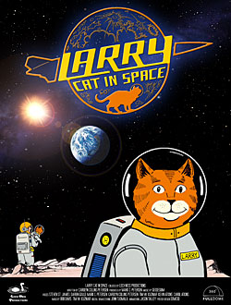  Pre K - 2 LARRY CAT IN SPACE (30 min) | Take off on a lunar adventure with a curious stowaway cat! Larry Cat in Space is a playful, imaginative cartoon presentation about an inquisitive cat who takes a trip to the Moon. Formerly a slide show planetarium program, adapted for the full dome system.
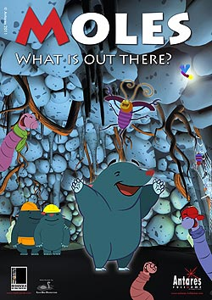  Pre K - 2 MOLES: WHAT'S OUT THERE? (36 min) | In this co-production of Albedo FullDome and Mediuscula, young children will be introduced to the fascinating world of astronomy in a fun, simple and very humorous way, hand in hand with Plato, a young mole. The animated characters and the attractive backdrops of this fulldome entertainment show will keep audiences captivated. With Moles, children will learn basic concepts about science while having a great time.
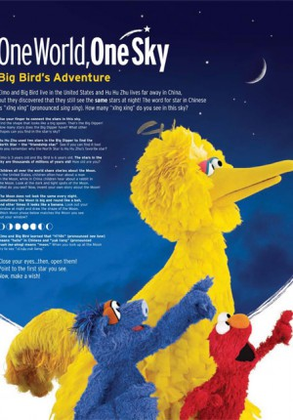  Pre K-2 One World, One Sky (27 min) | One World, One Sky is a 27-minute fulldome planetarium show that follows Sesame Street's Big Bird and Elmo as they explore the night sky with Hu Hu Zhu, a Muppet from Zhima Jie, the Chinese co-production of Sesame Street. Together, they take an imaginary trip from Sesame Street to the moon, where they discover how different it is from Earth.
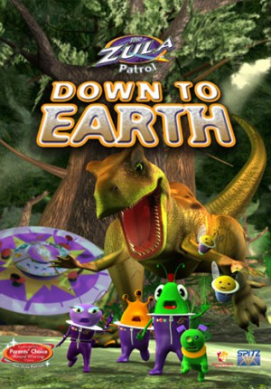  Grade1 - Grade 4 ZULA PATROL: DOWN TO EARTH (24 min) | While on a routine fossil-hunting expedition, the Zula Patrol turns up evidence that the villainous Deliria Delight has been travelling back in time to Earth’s prehistoric past to illegally dump her company’s toxic trash. The Zula Patrollers must find and catch her, before her actions cause catastrophic consequences. In the process, our heroes learn all about the formation and development of Earth, and the life forms who call it home.
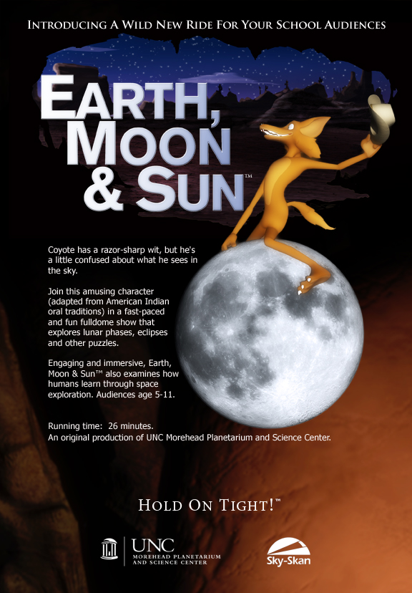  Grade 3 - Middle EARTH, MOON & SUN (35 min) | This planetarium show explores the relationship between the Earth, Moon and Sun with the help of Coyote, an amusing character adapted from Native American oral traditions who has many misconceptions about our home planet and its most familiar neighbors. His confusion about the universe makes viewers think about how the Earth, Moon and Sun work together as a system. Native American stories are used throughout the show to help distinguish between myths and science.
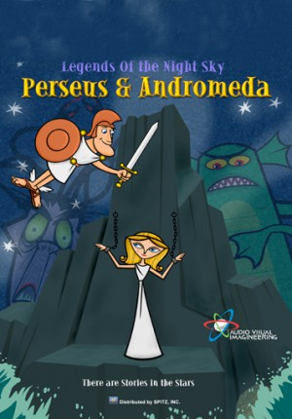  Grade 1 - High School LEGENDS OF THE NIGHT SKY: PERSEUS AND ANDROMEDA (18 min) | Perseus and Andromeda is a fun-filled retelling of the tale of the beautiful but unfortunate princess Andromeda, who in divine punishment for her mother’s bragging, is sacrificed to a sea monster—and rescued by the Greek hero Perseus.
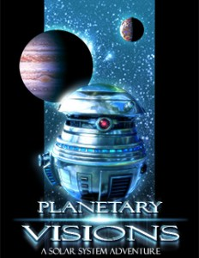  Grade 3 - 6 PLANETARY VISIONS - (36 min) | Explore the solar System in this exciting and interactive planetarium program! Be prepared to for an adventure that will leave you wondering if maybe you really did just get back from a mission in space! Fun for audiences of all ages!
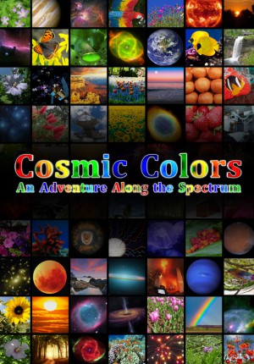  Grade 5 - Middle COSMIC COLORS (30 min) | Enjoy a wondrous journey through the world of color and beyond! Discover why the sky is blue, why Mars is red, and the reason why many things are the color that they are. Tour the interior of a plant leaf, voyage through a human eye, then step into the invisible universe as you investigate x-rays by taking on a monstrous black hole. Explore the world of infrared in a roaring fire, and even discover what may have been the actual color of a dinosaur. Explore the amazing rainbow of cosmic light through COSMIC COLORS, an original production of the Daniel M. Soref Planetarium in cooperation with the Great Lakes Planetarium Association.
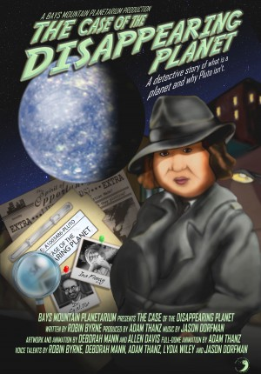  Grade 5 - Middle THE CASE OF THE DISAPPEARING PLANET (26 min) | THE CASE OF THE DISAPPEARING PLANET looks into the changing status of objects we call “planets.” It not only covers Pluto, but the temporary planetary status of asteroids as well. The tally of “planets” in our Solar System has been going up and down for hundreds of years! Have fun with this program as it features a sly, street-smart gumshoe called Skye Watcher. After a frenzied phone call from a 3rd grade teacher, she collects clues to ﬁnd out what happened to Pluto. This show is excellent as a school program that highlights the scientific method as well as understanding our Solar System.
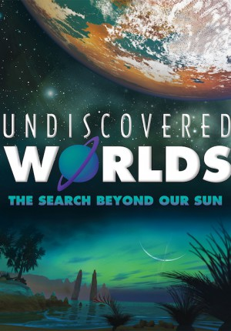  Middle - Adult UNDISCOVERED WORLDS: THE SEARCH BEYOND OUR SUN (30 min) | This show explores a timeless question: Do other planets like Earth exist? Through the discovery of exoplanets, the hundreds of planets that have been found orbiting stars beyond the Sun, we have learned that our solar system is not alone in the universe and have had to redefine our understanding of planets and solar systems. With rapidly improving technology and endeavors like the Kepler Telescope, the discovery of exoplanets represents one step closer to the possibility of finding an Earth-like world. How will this change how we view our place in the universe?
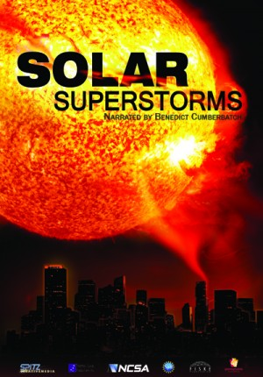  Middle - Adult SOLAR SUPER STORMS (24 min) | A fury is building on the surface of the Sun – high-velocity jets, a fiery tsunami wave that reaches 100,000 kilometers high, rising loops of electrified gas. What’s driving these strange phenomena? How will they affect planet Earth? Find the answers as we venture into the seething interior of our star. SOLAR SUPERSTORMS is a major new production that takes viewers into the tangle of magnetic fields and superhot plasma that vent the Sun’s rage in dramatic flares, violent solar tornadoes, and the largest eruptions in the solar system: Coronal Mass Ejections. The show features one of the most intensive efforts ever made to visualize the inner workings of the sun, including a series of groundbreaking scientific visualizations computed on the giant new supercomputing initiative, Blue Waters, based at the National Center for Supercomputing Applications (NCSA), University of Illinois. Brace yourself for the onslaught of the next… Solar Superstorm.
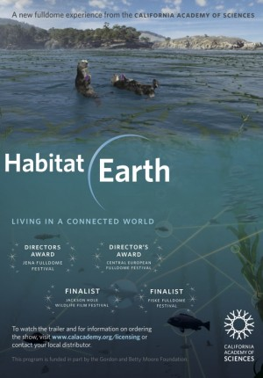  Middle - Adult HABITAT EARTH (25 min) | Living networks connect and support life forms large and small—from colonies of tiny microbes and populations of massive whales to ever-expanding human societies. In the California Academy of Sciences’ latest original planetarium show, Habitat Earth, discover what it means to live in today’s connected world. Through stunning visualizations of the natural world, dive below the ocean’s surface to explore the dynamic relationships found in kelp forest ecosystems, travel beneath the forest floor to see how Earth’s tallest trees rely on tiny fungi to survive, and journey to new heights to witness the intricate intersection between human and ecological networks.
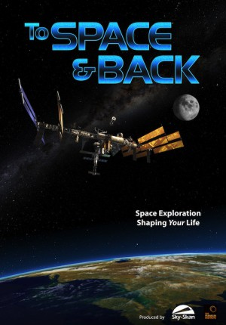  Middle - Adult TO SPACE AND BACK (25 min) | Space exploration — our greatest adventure — is having a big impact on our lives. It’s helping us to discover a universe of unimaginable scale and beauty, and it’s reaching down into our world and influencing the way we live. TO SPACE AND BACK takes audiences on an incredible journey from the far reaches of our known universe to our own planet. It is an extraordinary story of human ingenuity and incredible engineering, describing how the technology that transports us through space is paving the way for the devices and apps we use every day. What’s happening above is coming back down to Earth! Discover how we’ve been changed by space exploration, and what we owe to curiosity and the spirit of discovery.
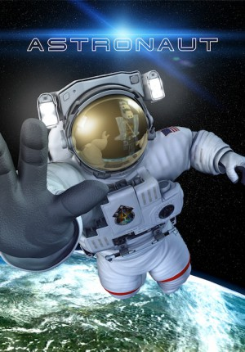  Middle - Adult ASTRONAUT (23 min) | The exploration of space is the greatest endeavour that humankind has ever undertaken. What does it take to be part of this incredible journey? What does it take to become an astronaut? Experience a rocket launch from inside the body of an astronaut. Explore the amazing worlds of inner and outer space, from floating around the International Space Station to maneuvering through microscopic regions of the human body. Discover the perils that lurk in space as we subject ‘Chad’, our test astronaut, to everything that space has to throw at him.
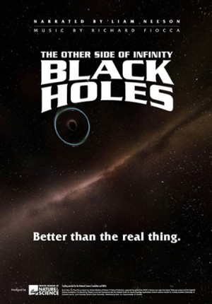  Middle - Adult BLACK HOLES: THE OTHER SIDE OF INFINITY (22 min) | This cutting-edge production features high-resolution visualizations of cosmic phenomena, working with data generated by computer simulations, to bring the current science of black holes to the dome screen.Audiences will be dazzled with striking, immersive animations of the formation of the early universe, star birth and death, the collision of giant galaxies, and a simulated flight to a super-massive black hole lurking at the center of our own Milky Way Galaxy. Narrated by Liam Neeson.
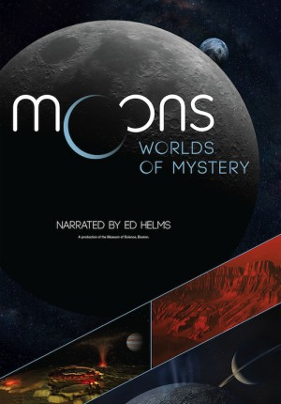  Middle - Adult MOONS: WORLDS OF MYSTERY (35 min) | Moons: Worlds of Mystery immerses you in the amazing diversity of moons and the important roles they play in shaping our solar system. Follow in the footsteps of astronauts to our silvery Moon, then venture beyond to unfamiliar and exotic worlds. Journey to the outer planets and their moons, returning home with newfound wonder about the dynamic and intricate solar system in which we all live.
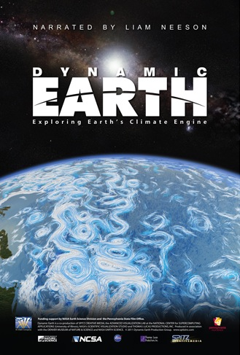  Middle - Adult - DYNAMIC EARTH (24 min) | Explore the inner workings of Earth’s great life support system: the global climate. With visualizations based on satellite monitoring data and advanced supercomputer simulations, this cutting-edge production follows a trail of energy that flows from the Sun into the interlocking systems that shape our climate: the atmosphere, oceans, and the biosphere. Audiences will ride along on swirling ocean and wind currents, dive into the heart of a monster hurricane, come face-to-face with sharks and gigantic whales, and fly into roiling volcanoes.
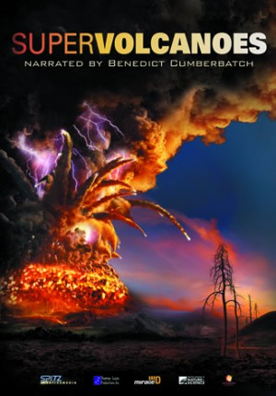  Middle - Adult SUPER VOLCANOES (24 min) | An immersive planetarium show that looks back at rare classes of eruptions that have marshaled the energy that lurks, like a sleeping dragon, beneath the surface of planet Earth. The program moves beyond Earth to explore the impact of giant volcanic eruptions around our solar system. Audiences will fly down to Neptune’s frigid moon Triton, and onto the ultimate volcanic world: Jupiter’s moon Io. On a visit to a legendary North American hot spot, Yellowstone National Park, the film asks: can a supervolcano erupt in our time?
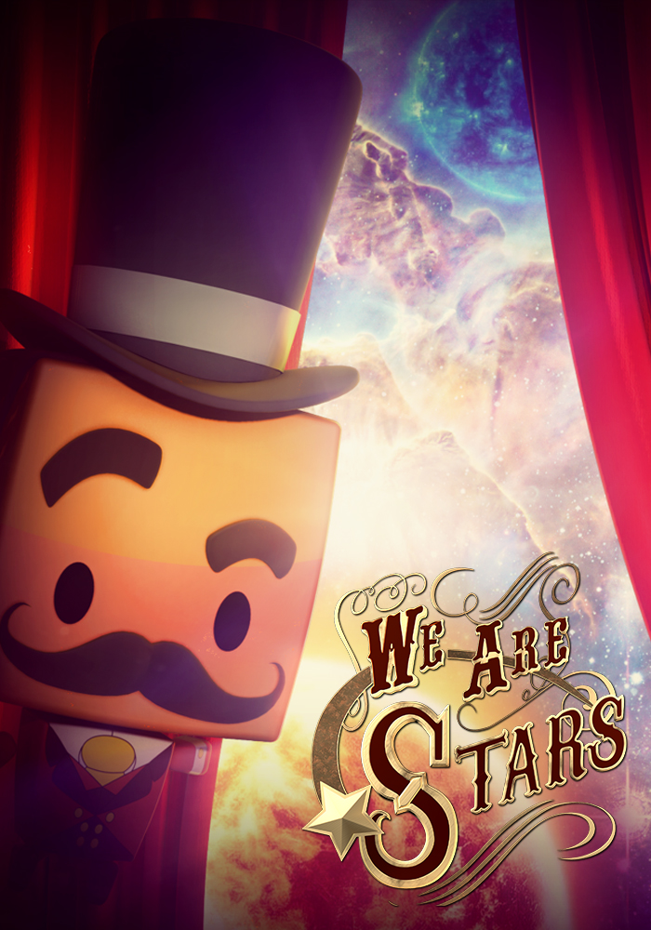  Middle - Adult WE ARE STARS (25 min) | What are we made of? Where did it all come from? Explore the secrets of our cosmic chemistry, and our explosive origins. Connect life on Earth to the evolution of the Universe by following the formation of Hydrogen atoms to the synthesis of Carbon, and the molecules for life. Narrated by Andy Serkis.
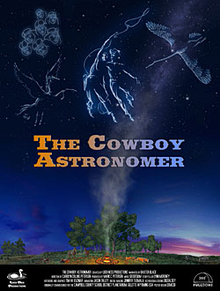  Middle - Adult THE COWBOY ASTRONOMER (37 min) | THE COWBOY ASTRONOMER is a skillfully woven tapestry of star tales and Native American legends, combined with constellation identification, star-hopping, and astronomy tidbits — all told from the unique viewpoint of a cowboy astronomer who has traveled the world plying his trade and learning the sky along the way.
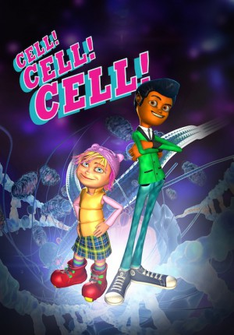  Middle - Adult CELL, CELL, CELL (24 min) | You are made of 70 trillion living cells. They work. They talk. They think. They are what make you alive.This is the story of the trillions of cells that form our bodies, from our beginnings as a single cell to the complexity of a whole body: it’s the story of who we are. Join Raj and Sooki on a totally ex-CELL-ent immersive journey. Get shrunk down by the Shrink-a-tron, go back in time with the Retroscope and see an exploded view of all the body systems courtesy of the Cell-o-tron.
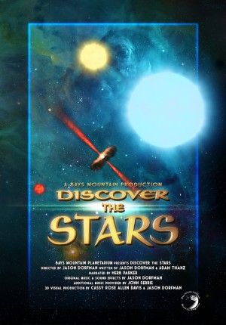  Middle - Adult - DISCOVER THE STARS (23 min) | On a clear, dark night, most of us, at one time or another, have gazed upon the stars and wondered about all those tiny points of light. Many of us are able to identify different patterns and constellations in the stars. But, what are those tiny points of light? This exciting program takes viewers beyond a simple observation of the night sky and delves into the fascinating lives of stars. The show can run straight through or be paused at a specific point for an additional live, interactive presentation to enhance the program.
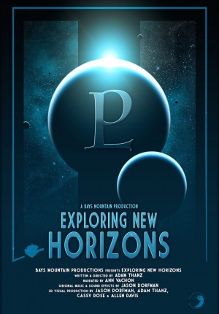  Middle - Adult - EXPLORING NEW HORIZONS (30 min) | “Exploring New Horizons” is a full-dome planetarium show that explores the New Horizons spacecraft and its mission to dwarf planet Pluto and other KBOs. This program also exhibits the importance of the scientific method and how it applies to our understanding of the Solar System. Starting from ancient times, learn about the history of planetary discovery, especially that of Pluto, and how it has led to an amazing mission to explore the Kuiper Belt.
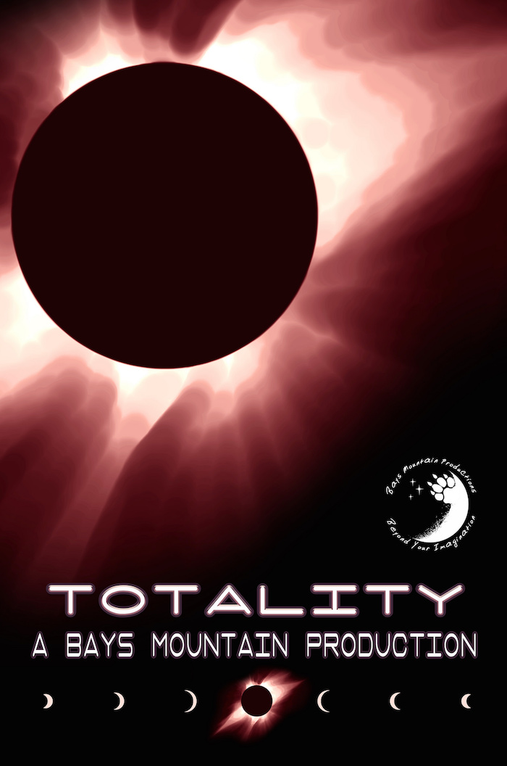  Middle - Adult - TOTALITY (25 min) | - TOTALITY – This program is all about eclipses – from lunar to total solar. We cover how they occur and what happens when they do. We look back to the proof of general relativity and look forward to upcoming eclipses and where to witness them. Our production includes a variety of wonderful styles – from spectacular space environments to humorous pop-up books. A very special part of the show relates, in a very human way, what happens when you are caught in the shadow of the Moon and the Sun is plunged into a total solar eclipse.

