THAT’S NO SPACE STATION
JUNE 2013
MOON #2 TITAN
THAT’S NO PLANET
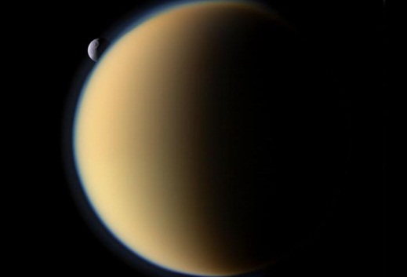
A world enshrouded in a thick haze. Rain falls from clouds drifting through the mostly nitrogen atmosphere filling rivers, lakes and seas, all while tectonic forces constantly shape the ground below. This isn’t Earth, or even a newly discovered exoplanet hundreds of light years away. This is Titan, the second largest moon in the solar system, a mere 790,000,000 miles away, orbiting the giant ringed planet Saturn. And that’s not liquid water falling from those clouds, much too cold for that. The frigid temperatures of Titan (as cold as -290° F) instead make methane the liquid of choice in the seas and rivers on Titan’s bitter cold surface. But before we get into what makes Titan the second most interesting moon in the solar system (based on a thorough, 1 person survey of the most interesting moons in the solar system) let’s get some background on this amazing satellite.

A LITTLE HISTORY
Titan was the first moon to be discovered orbiting the planet Saturn by a figure many of you will have heard of, Christiaan Huygens. The namesake for the famous Huygen’s lander that was dropped onto Titan to study its thick atmosphere was one half of a dynamic telescope manufacturing pair who revolutionized the way in which telescopes are made. Many of you may be thinking, “I’ll be it’s Andy Smetzer, he built his own telescope!” Unfortunately, though Andy made a great scope, Christiaan Huygens was around just a little before Andy’s time. Instead the other half of this dynamic duo was his brother, Constantijn. Christiaan and Constantijn came from a wealthy family and so had the resources to make some fine observing equipment. Of course it didn’t hurt that they were really smart too. Christiaan deduced the law of refraction which not coincidently helped him to build telescopes to very accurate specifications and also developed new strategies for grinding and polishing lenses. In 1655 Huygens aimed one of his telescopes at majestic Saturn with the intention of studying its vast ring system and was surprised to see a moon orbiting the giant planet. He creatively named it Saturni Luna, which is Latin for…Saturn’s Moon. (Hey, you can’t be good at everything.) Titan was not officially named Titan until John Hershel, who discovered the most interesting battle station, er, moon in the solar system, Mimas, named it Titan in 1847. Titan is also referred to as Saturn VI, another imaginative label bestowed upon it long before John Hershel got around to giving it the name we use today.

HOW KNOW WHAT WE KNOW
As Fraser Cain so eloquently puts it at the beginning of every episode of Astronomy Cast (which you should check out by the way on iTunes, especially episode 201 Titan), it’s not just about “what we know, but how we know, what we know”. Obviously it all began with Christiaan Huygens and his telescope. You can repeat his feat by getting your telescope out and pointing it at Saturn. Even users with small scopes can generally pick out this brightest satellite of Saturn. Of course this is really just about all people could do for hundreds of years after its discovery. Fortunately for us, technology has gotten a little better since the 1600s and now we know much more about this alien world, thanks to some man made satellites of our own.

VOYAGING PIONEERS
The first man made satellite to image Titan was the Pioneer 11 spacecraft in 1979, but these were low quality and not very close up images. In 1980 and 1981, Voyager 1 and 2 respectively took some closer images, with Voyager 1 making a planned close pass of the Saturnian moon. Unfortunately the imaging equipment aboard Voyager 1 could not penetrate the thick atmosphere of Titan and so surface features were not directly imaged at that time. Voyager 2 did not get as close as its trajectory could not be altered for a close flyby of Titan before it headed out to visit the two outermost planets of our solar system.

HUYGENS…HE’S BAAACK (OH, AND CASSINNI TOO)
As cool as these three missions may have been, the real fun began in 2004 as the joint NASA/ESA Cassinni-Huygens mission (named after Christiaan Huygens and Giovanni Cassinni who discovered four other moons of Saturn) reached Saturnian system and began to map the surface of Titan. In early 2005 the Huygens probe landed on the surface of Titan, taking photos as it fell through the atmosphere of Titan, including one from the surface of the moon that showed rocks, likely composed of water ice, lying on a plain. The photos taken by the probe showed evidence of moving liquid on the surface of Titan in the past, while the Cassinni orbiter has definitively found liquid lakes, seas at the north pole of the gigantic moon.

WHY IT’S THE SECOND COOLEST MOON IN OUR SOLAR SYSTEM
So why does this moon deserve the title of second coolest moon in the solar system? Well first of all you just can’t beat a real life Death Star, so Mimas was the obvious and unanimous choice for coolest moon in the solar system. (1 of 1 people recommended it.) But it just beat out one of Jupiter’s moons (I can’t say which, you’ll just have to wait for #3 to hit the newsletter) for # 2 on this list because it’s the most Earth like world in our entire solar system. Mostly nitrogen atmosphere about four times as dense as our own, a liquid cycle, much like our water cycle here on earth, tectonic forces shaping the surface , and a myriad of things we haven’t yet discussed make this possibly the most scientifically interesting body in our solar system save the earth itself. In fact Earth could have been very similar to Titan, though much warmer, billions of years ago before life took hold. As the sun changes over billions of years, Titan may even become habitable in the future. We’ll just have to wait around for a little while to see.

IN CONCLUSION, BUT NOT REALLY
In conclusion, this is not the end. Next month we’ll focus on Saturn’s giant moon yet again, but we’ll get more in-depth into the atmospheric and surface features that make Titan truly worthy of being the second most interesting moon in our solar system! In the meantime, check out some suggested resources for further study of Titan at www.

