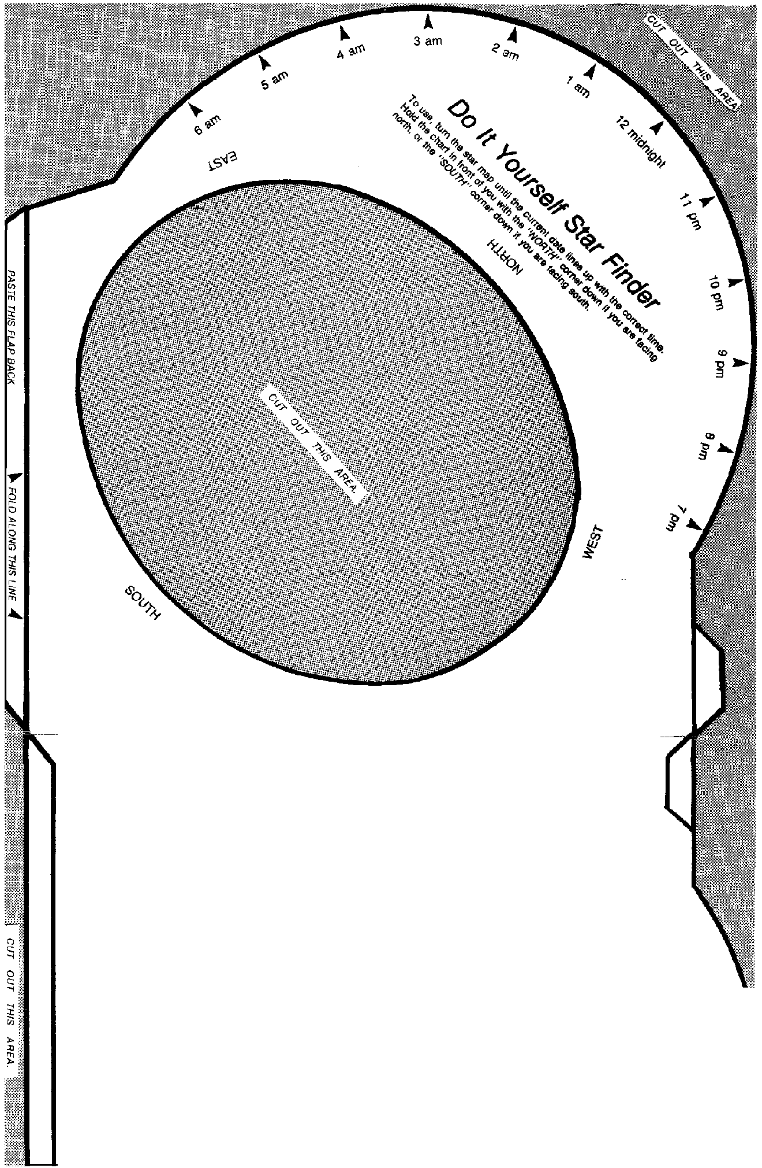

*F-01* fJ *AI O."''G THIS UNE*

The *Do It Yourself Star Finder* is an adaptatiort of the *Sky Chatrenger* which was designed by Budd Wentz and Gdapted for classroom use by Edna DeV:ne of the Lawrence Hall of Science, University of California at Berkeley, Berkeley, CA 94720. The *Sky Challenger* was

originally developed under National Science Foundation Granr

#SED 77-Hl8l8. @1978 Regents of the University of California.